ITEC 4200 Advanced Database Systems
Semester Project

Part 4. SQL QUERIES
Create queries to retrieve different information from your database. Here is a list of requirements for each query:
- Each query must be saved in one SQL script (all in one script)
- Include a comment as the first line of each query that explains in plain English what the query displays
- All queries must have output ordered by one or more column.
- All columns must have an alias,
- The results of the query should be nicely formatted.
- The column widths should be adjusted so that one row fits on one line of output.

Your printout should show:
The explanation, followed by the SQL code, followed by the results of the query. The easiest way to do this is to take a screenshot of each query, as shown:

For example:
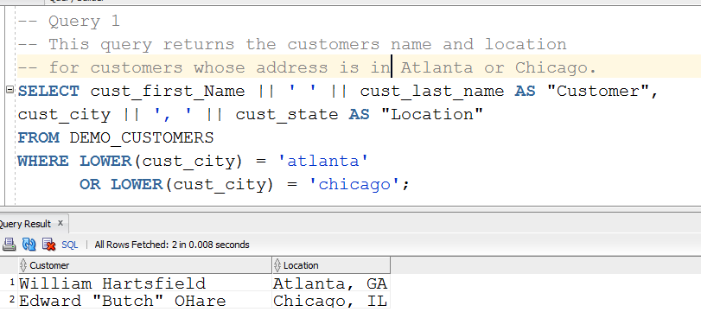
Crop your screenshots, so there is not a lot of extra stuff all around the main information.

You must have the following types of queries (Q1, Q2, Q3, etc.):
Q1: Compound condition (AND or OR) in the WHERE clause
(Note: BETWEEN is not a compound condition.)
Q2: CASE or DECODE statement
(Note: You must have at least TWO alternatives.)
Q3: One of the built-in aggregate functions, such as SUM, AVG, COUNT, MAX, etc.
Q4: Join of two or more tables
Q5: A single-value sub-query
Q6: Set operator
Q7: Date function (Note: TO_DATE and TO_CHAR are not a date functions)
Q8: One of the data conversion functions (TO_CHAR, TO_DATE, or TO_NUMBER)
Q9: Multiple-value sub-query
Q10: Outer join
(Note: Your output must show how the outer join includes rows from one table that do not have a match with a row in the other table. That is, the results of this query must contain at least one orphan. You may have to adjust your data so that the outer join works correctly.)
For the two sub-queries, be careful not to make a sub-query that doesn’t actually do anything. This will not count as an appropriate use of a sub-query. For example:

SELECT empname “Name”, empno “Number
FROM employee
WHERE empno IN (SELECT empno
FROM employee
WHERE deptno = 50);

The WHERE clause could be replaced with the simpler expression:
WHERE deptno = 50;

So in this case, the subquery doesn’t provide any new information, and thus is not necessary. You must write a subquery that provides some new information to the main query.

What to turn in for Part 4: Print out the query and query run for all 10 queries, as shown in the example above.

DO NOT PRINT OUT THE ALL OF THE SQL CODE, FOLLOWED BY ALL OF THE RESULTS AND EXPECT DR. POLLACIA TO SORT IT OUT. 30 points will be deducted for doing this. You must show the query and the run of the query together, then go to the next query, and so on. The easiest way to do this is to take a screenshot of each query with the results, as shown above, and put them in a Word document.

Note that there are no “do-overs” for Parts 4 and 5. So please read and adhere to these specifications carefully.

Also upload all queries to the Semester Project folder in D2L.

Part 5. REPORT
Create a reports (report file) as described below:

Report 1: This report will list records from one or more of the tables with a control break based on one of the fields. The records should be sorted by one or more fields. You must use a top title, a bottom title, column headings and good spacing. All dollar figures must be formatted with dollar sign, comma, and zero decimal places. Write an explanation as to what information the report produces. Save as report1.

What to turn in for Part 5: Print out the code and the run for the report. Upload Report1 to D2L folder. Remember to write a brief explanation of what the report is supposed to do.

When you are ready to turn the report in for grading, issue the following commands in SQL*Plus (Command line). Suppose you have saved the report in C:\Oracle folder.
SQL> spool C:\Oracle\Semester_Report
SQL> get C:\Oracle\Report1 (this will display the report)
SQL> @ C:\Oracle\Report1 (this will run the report. )
SQL>spool off
The spooler saves everything that appears on the screen from the time you turn it on until you specify spool off. Then you can print out the spooled file:
C:\Oracle\Semester_Report.LST

